**Experiment 3**

**Image Processing Basics in OpenCV**

**Aim:**

1. To implement the following basic functions on an image or a video in Open CV:

Convert to Gray Scale, implement image intensity transformations, Blur, Draw shapes and adding Text, Mask or Crop, Histogram, Thresholding, Image Addition and Image Subtraction.

# **Software/ Packages Used:**

1. Pycharm IDE
2. Libraries used:
   * NumPy
   * opencv-python
   * matplotlib
   * scipy

# **Programs:**

# 

# **To implement the basic functions of image processing in openCV**

# **Image intensity transformations**

# **Image Negative**

import cv2 as cv  
import numpy as np  
img=cv.imread("C:/Users/21r228\Downloads\download.jpg")  
print("img.itype")  
print("img")  
img_res=255-img  
cv.imshow("1",img)  
cv.imshow("2",img_res)

**IMAGE NEGATIVE:**

**INPUT: OUTPUT:**

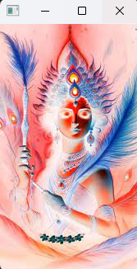

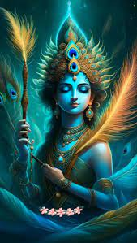

**PIXEL MATRIX:**

**IMAGE:**

[[41 42 8]

[41 42 8]

[42 42 6]

...

[35 34 6]

[29 28 0]

[29 28 0]]

**IMAGE_REVERSE:**

[[214 213 247]

[214 213 247]

[213 213 249]

...

[220 221 249]

[226 227 255]

[226 227 255]]

cv.waitKey(0)  
cv.destroyAllWindows()

# **Logarithmic Transformation**

import cv2 as cv  
import numpy as np  
  
# Open the image.  
img = cv.imread("C:/Users/21r228\Downloads\download.jpg")  
  
# Apply log transform.  
c = 255/(np.log(1 + np.max(img)))  
log_transformed = c * np.log(1 + img)  
  
# Specify the data type.  
log_transformed = np.array(log_transformed, dtype = np.uint8)  
  
# Save the output.  
cv.imwrite('log_transformed.jpg', log_transformed)  
cv.waitKey(0)  
cv.destroyAllWindows()

# **Power Law (Gamma) Transformation**

import cv2 as cv

import numpy as np

# Open the image.

img = cv.imread('C:/Users/21r228\Downloads\download.jpg')

# Trying 4 gamma values.

for gamma in [0.1, 0.5, 1.2, 2.2]:

# Apply gamma correction.

gamma_corrected = np.array(255 * (img / 255) ** gamma, dtype='uint8')

# Save edited images.

cv.imwrite('gamma_transformed' + str(gamma) + '.jpg', gamma_corrected)

cv.waitKey(0)

cv.destroyAllWindows()

# **LOGARITHMIC TRANSFORMATION**

**INPUT: OUTPUT:**

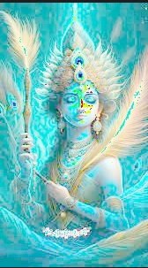

# **Power Law (Gamma) Transformation**

**INPUT:**



**OUTPUT:**

0.1 0.5 1.2 2.2

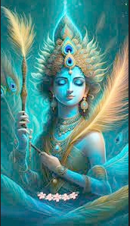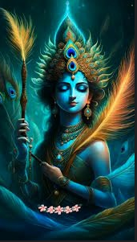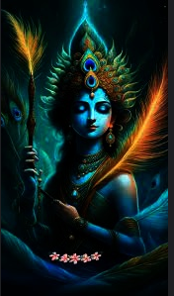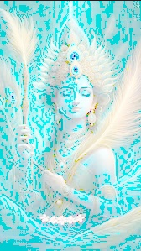

# **Contrast stretching**

import cv2  
import numpy as np  
  
# Function to map each intensity level to output intensity level.  
def pixelVal(pix, r1, s1, r2, s2):  
 if (0 <= pix and pix <= r1):  
 return (s1 / r1)*pix  
 elif (r1 < pix and pix <= r2):  
 return ((s2 - s1)/(r2 - r1)) * (pix - r1) + s1  
 else:  
 return ((255 - s2)/(255 - r2)) * (pix - r2) + s2  
  
# Open the image.  
img = cv2.imread('C:/Users/21r228\Downloads\download.jpg')  
  
# Define parameters.  
r1 = 70  
s1 = 0  
r2 = 140  
s2 = 255  
  
# Vectorize the function to apply it to each value in the Numpy array.  
pixelVal_vec = np.vectorize(pixelVal)  
  
# Apply contrast stretching.  
contrast_stretched = pixelVal_vec(img, r1, s1, r2, s2)  
  
# Save edited image.  
cv2.imwrite('contrast_stretch.jpg', contrast_stretched)  
cv2.waitKey(0)  
cv2.destroyAllWindows()

**CONTRAST STRETCHING**

**INPUT:**



**OUTPUT:**

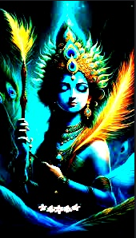

# **Bit plane slicing**

import numpy as np  
import cv2  
  
# Read the image in greyscale  
img = cv2.imread('C:/Users/21r228\Downloads\download.jpg', 0)  
  
# Iterate over each pixel and change pixel value to binary using np.binary_repr() and store it in a list.  
lst = []  
for i in range(img.shape[0]):  
 for j in range(img.shape[1]):  
 lst.append(np.binary_repr(img[i][j], width=8)) # width = no. of bits  
  
# We have a list of strings where each string represents binary pixel value. To extract bit planes we need to iterate over the strings and store the characters corresponding to bit planes into lists.  
# Multiply with 2^(n-1) and reshape to reconstruct the bit image.  
eight_bit_img = (np.array([int(i[0]) for i in lst], dtype=np.uint8) * 128).reshape(img.shape[0], img.shape[1])  
seven_bit_img = (np.array([int(i[1]) for i in lst], dtype=np.uint8) * 64).reshape(img.shape[0], img.shape[1])  
six_bit_img = (np.array([int(i[2]) for i in lst], dtype=np.uint8) * 32).reshape(img.shape[0], img.shape[1])  
five_bit_img = (np.array([int(i[3]) for i in lst], dtype=np.uint8) * 16).reshape(img.shape[0], img.shape[1])  
four_bit_img = (np.array([int(i[4]) for i in lst], dtype=np.uint8) * 8).reshape(img.shape[0], img.shape[1])  
three_bit_img = (np.array([int(i[5]) for i in lst], dtype=np.uint8) * 4).reshape(img.shape[0], img.shape[1])  
two_bit_img = (np.array([int(i[6]) for i in lst], dtype=np.uint8) * 2).reshape(img.shape[0], img.shape[1])  
one_bit_img = (np.array([int(i[7]) for i in lst], dtype=np.uint8) * 1).reshape(img.shape[0], img.shape[1])  
  
# Concatenate these images for ease of display using cv2.hconcat()  
finalr = cv2.hconcat([eight_bit_img, seven_bit_img, six_bit_img, five_bit_img])  
finalv = cv2.hconcat([four_bit_img, three_bit_img, two_bit_img, one_bit_img])  
  
# Vertically concatenate  
final = cv2.vconcat([finalr, finalv])  
  
# Display the images  
cv2.imshow('a', final)  
cv2.waitKey(0)

# **Bit plane slicing**

**INPUT:**



**OUTPUT:**

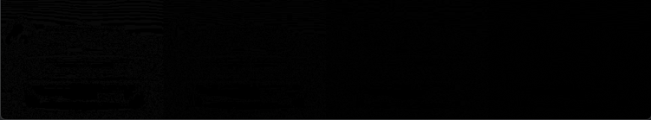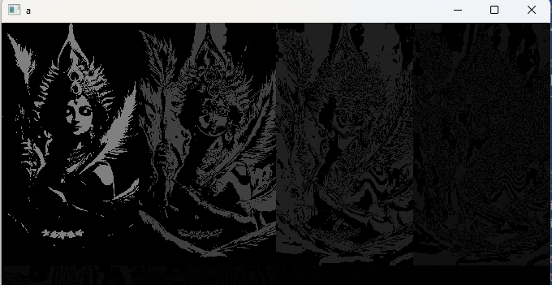

# **Paint and Draw on an image**

# # 1. Paint the image with certain color

# # 2. Draw a Rectangle

# # 3. Draw a circle

# # 4. Draw a line

# # 5. Write text

# Python3 program to draw solid-colored

# image using numpy.zeroes() function

import numpy as np

import cv2

# Creating a black image with 3 channels

# RGB and unsigned int datatype

img = cv2.imread("C:/Users/21r228\Downloads\long-exposure-photo-1024x576.jpg")

# Creating line

cv2.line(img, (120, 160), (500, 160), (0, 0, 255), 10)

# Creating rectangle

cv2.rectangle(img, (30, 30), (500, 400), (0, 255, 0), 5)

# Creating circle

cv2.circle(img, (200, 200), 80, (255, 0, 0), 3)

# writing text

font = cv2.FONT_HERSHEY_SIMPLEX

cv2.putText(img, 'T.G.SON', (100, 100),

font, 0.8, (0, 255, 0), 2, cv2.LINE_AA)

cv2.imshow('dark', img)

# Allows us to see image

# until closed forcefully

cv2.waitKey(0)

cv2.destroyAllWindows()

# **Paint and Draw on an image**

**INPUT**

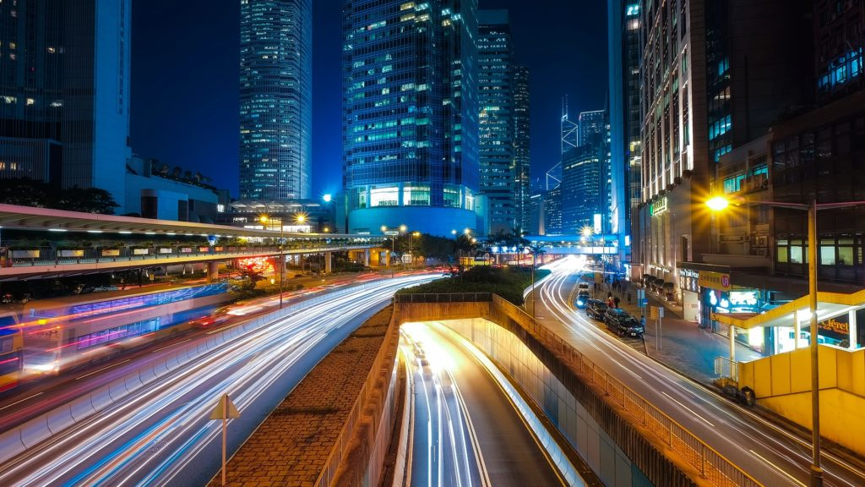

**OUTPUT**

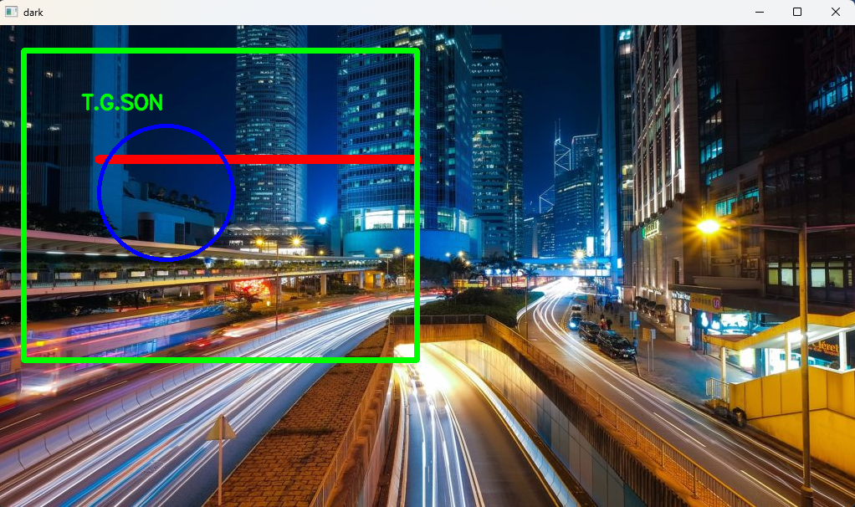

# **IMAGE MASKING:**

# import required libraries

import cv2

import numpy as np

# read input image

img = cv2.imread('C:/Users/21r228\Downloads\download.jpg')

# Convert BGR to HSV

hsv = cv2.cvtColor(img, cv2.COLOR_BGR2HSV)

# define range of blue color in HSV

lower_yellow = np.array([15,50,180])

upper_yellow = np.array([40,255,255])

# Create a mask. Threshold the HSV image to get only yellow colors

mask = cv2.inRange(hsv, lower_yellow, upper_yellow)

# Bitwise-AND mask and original image

result = cv2.bitwise_and(img,img, mask= mask)

# display the mask and masked image

cv2.imshow('Mask',mask)

cv2.waitKey(0)

cv2.imshow('Masked Image',result)

cv2.waitKey(0)

cv2.destroyAllWindows()

**MASKING IMAGE:**

**INPUT:**



**OUTPUT:**

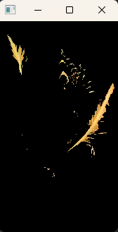

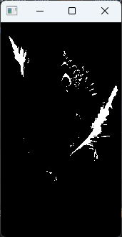

1. **MASKING THE IMAGE VIDEO**

import cv2

import numpy as np

cap = cv2.VideoCapture(0)

while (1):

_, frame = cap.read()

# It converts the BGR color space of image to HSV color space

hsv = cv2.cvtColor(frame, cv2.COLOR_BGR2HSV)

# Threshold of blue in HSV space

lower_blue = np.array([60, 35, 140])

upper_blue = np.array([180, 255, 255])

# preparing the mask to overlay

mask = cv2.inRange(hsv, lower_blue, upper_blue)

# The black region in the mask has the value of 0,

# so when multiplied with original image removes all non-blue regions

result = cv2.bitwise_and(frame, frame, mask=mask)

cv2.imshow('frame', frame)

cv2.imshow('mask', mask)

cv2.imshow('result', result)

cv2.waitKey(0)

cv2.destroyAllWindows()

cap.release()

**MASKING THE IMAGE VIDEO**

**INPUT:**

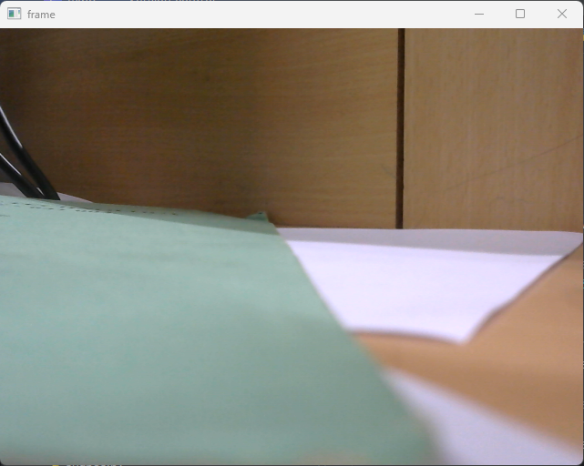

**OUTPUT:**

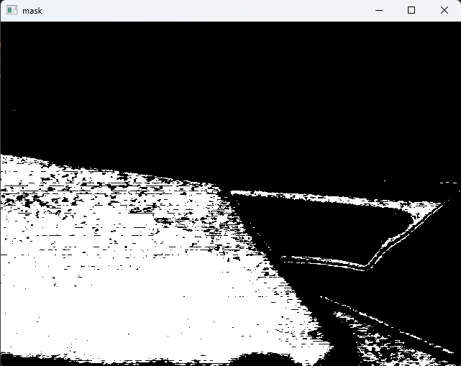

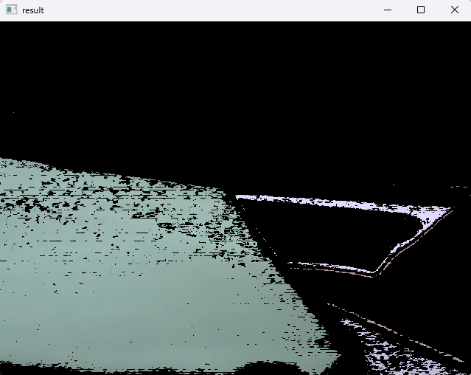

1. **Histogram**

# importing required libraries of opencv  
import cv2  
  
# importing library for plotting  
from matplotlib import pyplot as plt  
  
# reads an input image  
img = cv2.imread("C:/Users\RAGHUL\Downloads\Green and Black Dynamic Geometric Sport Instagram Post.png",0)  
  
# find frequency of pixels in range 0-255  
histr = cv2.calcHist([img],[0],None,[256],[0,256])  
  
# show the plotting graph of an image  
plt.plot(histr)  
plt.show()

1. **Histogram Equalization**

# import Opencv

import cv2

# import Numpy

import numpy as np

# read a image using imread

img = cv2.imread(\'F:\\do_nawab.png\', 0)

# creating a Histograms Equalization

# of a image using cv2.equalizeHist()

equ = cv2.equalizeHist(img)

# stacking images side-by-side

res = np.hstack((img, equ))

# show image input vs output

cv2.imshow(\'image\', res)

cv2.waitKey(0)

cv2.destroyAllWindows()

**Histogram**

**Input: Output:**

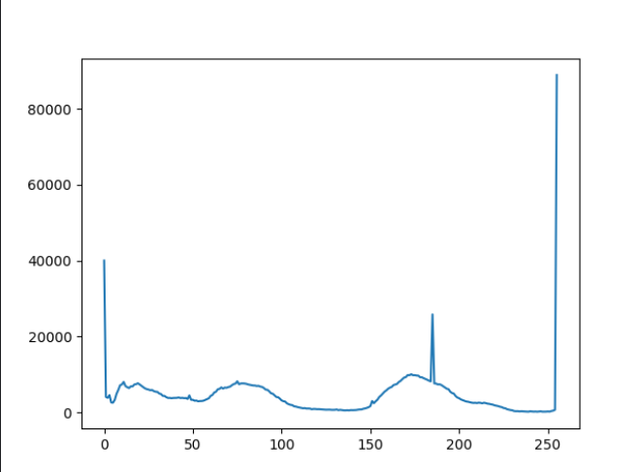

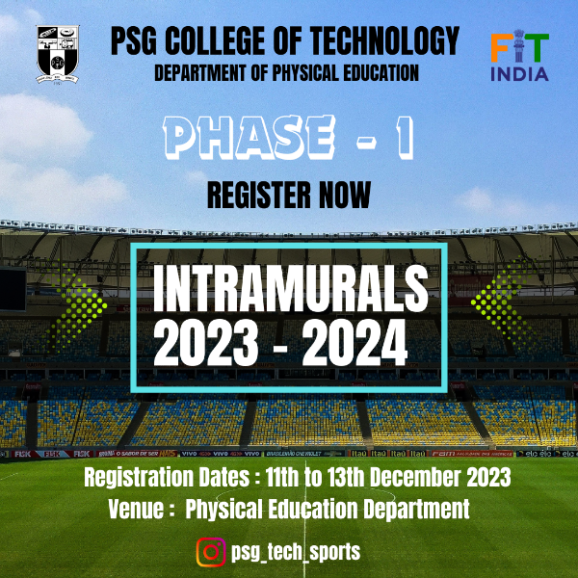

**Histogram Equalization**

**Input: Output:**



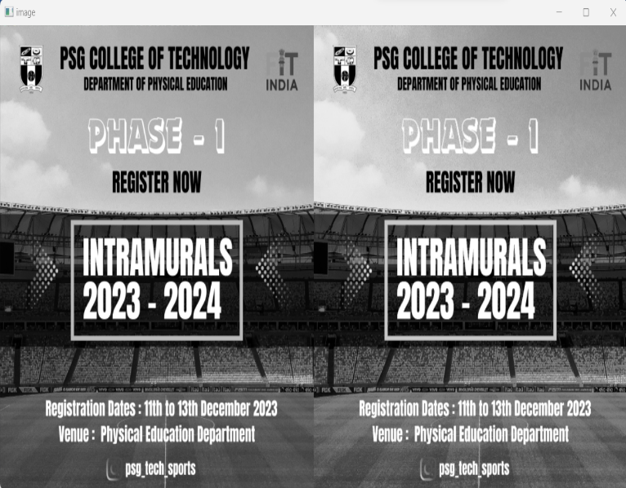

**Image Cropping:**

**Input: Output:**

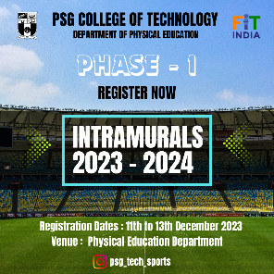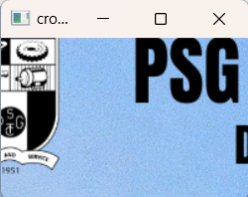

1. **Image Cropping:**

import cv2

img = cv2.imread("test.jpeg")

print(type(img))

# Shape of the image

print("Shape of the image", img.shape)

# [rows, columns]

crop = img[50:180, 100:300]

cv2.imshow('original', img)

cv2.imshow('cropped', crop)

cv2.waitKey(0)

cv2.destroyAllWindows()

**Post Lab Questions:**

1. What are the applications of masking and cropping in image processing?

2. Write a program to apply a circular mask on an image

3. What are the different functions available in OpenCV and Numpy packages to

calculate the histogram and histogram equalization of an image?

4. Write a program to find the coordinates of an image

5. What impact does masking a picture in a histogram have?

**Answers :**

**1.** Masking and cropping are common techniques used in image processing for various applications. Here's an overview of their applications:

* Object Segmentation:

Masking: Masks are used to isolate specific regions or objects within an image. By creating a binary mask, where the desired object is highlighted and the rest is masked out, object segmentation becomes possible. This is crucial in computer vision tasks like object detection and recognition.

Cropping: Once an object is identified using masking, cropping can be applied to extract and focus on that particular region of interest (ROI). This is useful in applications where the precise location and boundaries of an object need to be determined.

* Image Editing:

Masking: In image editing software, masking is commonly used to selectively apply changes to specific parts of an image. For example, you can apply filters, adjustments, or effects only to the regions defined by the mask, leaving the rest of the image unchanged.

Cropping: Cropping is a fundamental tool for framing and composition. It allows you to remove unwanted elements from an image and focus on the essential components. This is commonly used in photography and graphic design to improve the visual appeal of the image.

* Background Removal:

Masking: Masks are often employed for background removal, where the foreground object is separated from its background. This is particularly useful in e-commerce, product photography, and creating images with transparent backgrounds.

Cropping: Cropping can also be used for background removal, especially when the background is simple and the main object is centrally located. However, masking provides more flexibility in handling complex backgrounds.

* Image Annotation and Augmentation:

Masking: Masks are used for annotating objects in images, such as in computer vision datasets. They provide a precise delineation of object boundaries, aiding in the training of machine learning models.

Cropping: Cropping can be part of data augmentation strategies during training machine learning models. It helps in exposing the model to different scales and perspectives of the same object, enhancing its ability to generalize.

* Privacy Protection:

Masking: Masks can be applied to blur or hide specific regions of an image to protect privacy, such as faces or license plates. This is commonly used in applications like street view imagery.

Cropping: Cropping can be used to exclude sensitive information from an image, but masking is often preferred for more precise control over the areas to be protected.

In summary, masking and cropping are versatile techniques in image processing, providing solutions for object isolation, image editing, background removal, annotation, data augmentation, and privacy protection. Their applications extend across various fields, including computer vision, photography, graphic design, and machine learning.

**2.**

import cv2

import numpy as np

def apply_circular_mask(image_path, output_path, center, radius):

# Read the input image

img = cv2.imread(image_path)

# Create a black mask with the same size as the input image

mask = np.zeros_like(img)

# Generate a circular mask

cv2.circle(mask, center, radius, (255, 255, 255), thickness=-1)

# Apply the circular mask to the input image

result = cv2.bitwise_and(img, mask)

# Save the result to the output path

cv2.imwrite(output_path, result)

if __name__ == "__main__":

# Input and output file paths

input_image_path = "input_image.jpg"

output_image_path = "output_image_with_circular_mask.jpg"

# Center and radius of the circular mask

mask_center = (150, 150) # Example values; adjust as needed

mask_radius = 100 # Example value; adjust as needed

# Apply circular mask

apply_circular_mask(input_image_path, output_image_path, mask_center, mask_radius)

print(f"Circular mask applied. Result saved to {output_image_path}")

**3.**

Both OpenCV and NumPy provide functions to calculate histograms and perform histogram equalization on images.

**OpenCV Functions:**

1. Histogram Calculation:

- `cv2.calcHist(images, channels, mask, histSize, ranges[, hist[, accumulate]])`: Calculates the histogram of a set of images. Returns a dense or sparse histogram.

**Example:**

import cv2

import matplotlib.pyplot as plt

image = cv2.imread('image.jpg', cv2.IMREAD_GRAYSCALE)

hist = cv2.calcHist([image], [0], None, [256], [0, 256])

plt.plot(hist)

plt.title('Histogram')

plt.show()

2. Histogram Equalization:

cv2.equalizeHist(src[, dst])`: Equalizes the histogram of a grayscale image.

**Example:**

import cv2

image = cv2.imread('image.jpg', cv2.IMREAD_GRAYSCALE)

equalized_image = cv2.equalizeHist(image)

**NumPy Functions:**

1. Histogram Calculation

- `numpy.histogram(a, bins=10, range=None, normed=False, weights=None, density=None)`: Computes the histogram of a set of data.

**Example:**

import numpy as np

import matplotlib.pyplot as plt

image = cv2.imread('image.jpg', cv2.IMREAD_GRAYSCALE)

hist, bins = np.histogram(image.flatten(), bins=256, range=[0, 256])

plt.plot(hist)

plt.title('Histogram')

plt.show()

2. Histogram Equalization:

- NumPy itself doesn't have a built-in function for histogram equalization. However, you can use OpenCV in conjunction with NumPy:

**Example:**

import cv2

import numpy as np

image = cv2.imread('image.jpg', cv2.IMREAD_GRAYSCALE)

equalized_image = cv2.equalizeHist(image)

These functions help in visualizing and enhancing the contrast of an image by redistributing pixel intensities. Adjust the parameters as needed based on your specific use case.

**4.**

import cv2

# Global variables to store coordinates

coordinates = []

def mouse_callback(event, x, y, flags, param):

if event == cv2.EVENT_LBUTTONDOWN:

coordinates.append((x, y))

print(f"Coordinate clicked: ({x}, {y})")

if __name__ == "__main__":

# Read the image

image_path = "image.jpg" # Replace with the path to your image

img = cv2.imread(image_path)

if img is None:

print(f"Error: Unable to read the image at {image_path}")

else:

# Create a window and set the mouse callback function

cv2.namedWindow("Image")

cv2.setMouseCallback("Image", mouse_callback)

# Display the image

while True:

cv2.imshow("Image", img)

key = cv2.waitKey(1) & 0xFF

# Break the loop if the 'esc' key is pressed

if key == 27:

break

# Close the window

cv2.destroyAllWindows()

# Print the final coordinates

print("Final Coordinates:", coordinates)

**5.**

Masking a picture in a histogram involves selecting a specific region or subset of pixels within an image and analyzing the histogram only for that particular region. The impact of masking on a histogram can be significant, and it provides insights into the distribution of pixel intensities within the masked area. Here are some effects and considerations:

* **Isolation of Specific Regions:**

Impact: The primary purpose of masking in a histogram is to isolate specific regions or objects within an image. This allows you to analyze the pixel intensity distribution of only the selected area.

Use Case: Useful for focusing on certain objects or areas of interest, especially in complex images where different regions may have distinct characteristics.

* **Enhanced Contrast Analysis:**

Impact: Masking can help in enhancing contrast analysis by limiting the histogram computation to a specific region. This is beneficial when you want to observe the pixel intensity distribution in a localized part of the image.

Use Case: Useful for improving visibility and understanding the details within a specific region without being affected by the overall intensity distribution of the entire image.

* **Selective Image Editing:**

Impact: When editing an image, applying changes selectively to a masked region based on its histogram can lead to more controlled and targeted adjustments.

Use Case: Allows for localized image enhancement, such as adjusting brightness, contrast, or color balance, in specific areas without affecting the entire image uniformly.

* **Object Detection and Recognition:**

Impact: Masking in histograms is relevant for computer vision tasks like object detection. It helps in understanding the pixel intensity distribution of objects of interest.

Use Case: Useful when training machine learning models or developing algorithms that rely on the analysis of specific regions within images.

* **Background Removal:**

Impact: When removing the background from an image, masking and analyzing the histogram within the masked area can help ensure accurate selection and removal.

Use Case: Commonly employed in applications where the extraction of foreground objects is required, such as in image segmentation.

In summary, masking in a histogram has a localized impact, providing more focused insights into the pixel intensity distribution of specific regions within an image. This can be valuable for various image processing tasks, allowing for more precise analysis, editing, and understanding of localized features within an image.

# 

# **Result:**

Thus the basic image processing concepts were learnt using OpenCV in Pycharm IDE.